HOW TO APPLY TO THE EXCHANGE VISITOR PROGRAM

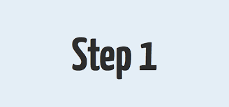

Determine which program is right for you.  See the program requirements comparison chart for an overview of each program category - *Interest Form*

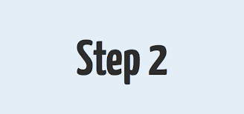

Contact the recruiting manager directly to participate in one exchange program. WMA will provide the applicant with specific information and application requirements.

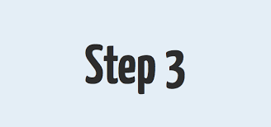

Sponsors are responsible for selecting candidates and supporting and monitoring them during their entire program.

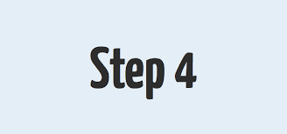

WMA will contact the qualified candidates and discuss the participant's program fees. Fees may vary from sponsor to sponsor and selective state. Candidates will receive a breakdown of all costs and expenses from sponsors before committing to a program.

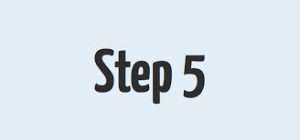

If you are accepted into an exchange program, the sponsor will issue you a Form DS-2019.

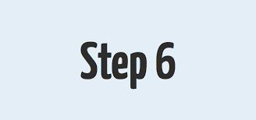

Pay the SEVIS (Student and Exchange Visitor Information System) fee at [www.fmjfee.com](http://www.fmjfee.com). Please retain a receipt for your records.

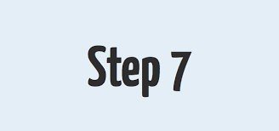

Go to the U.S Department of State website

ceac.state.gov/genniv to fill out an Online Nonimmigrant Visa Application Form DS-160 and pay the visa application fee of $160.00 Consult the website of the U.S embassy or consulate where you plan to apply for instructions on how to pay.

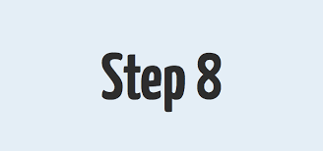

After you pay the visa application fee, schedule your interview- the earlier the better! Consult the website of the U.S embassy or consulate where you plan to apply for instructions on how to schedule it.

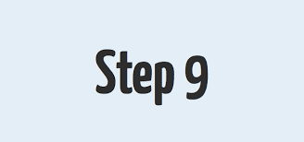

On the day of your interview, bring the following documents:

* An original DS-2019 form, Form DS-160 confirmation page
* Passport
* Photo and visa application fee receipt
* Consult the website of the U.S embassy or consulate where you plan to apply to check whether additional documents are needed.

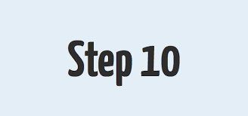

The interviewing officer will inform you at the end of the interview whether your visa is approved or denied. If approved, the interviewing officer will tell you when you should expect to receive your visa.

Continue to work with your sponsor to prepare to travel to the United States